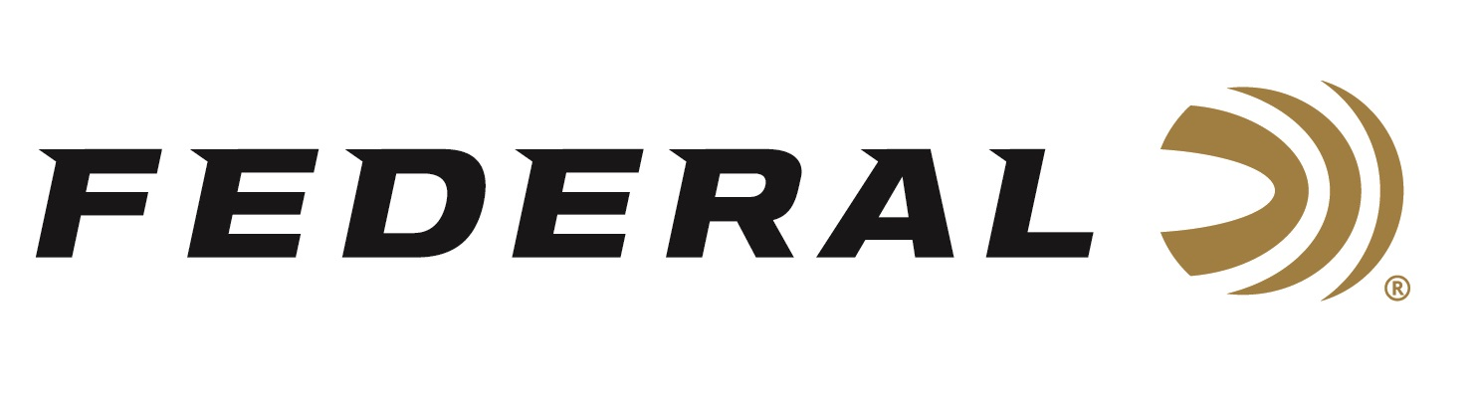

FOR IMMEDIATE RELEASE

Federal Ammunition Introduces Three New Top Gun 100-Packs

ANOKA, Minnesota – March 18, 2020 – Make clay crushing convenient with Top Gun 100-Packs. Each pack contains four 25-count boxes. Shipments of this product have begun to arrive at dealers.

The new bulk offerings hold 100 consistent Top Gun target loads, which feature hard lead pellets, reliable Federal primers and specialized wad columns that produce even patterns that break more targets. Two 12-gauge 2 ¾-inch, 1 1/8-ounce, 3-dram equivalent loads, shot size No. 7.5 or 8 are offered is these bulk packs. A 20-gauge, 2 ¾-inch, 7/8-ounce, 2.5-dram equivalent, shot size No. 8 is also available.

Features & Benefits
- Convenient 100-round packs
- Hard pellets
- Consistent, reliable Federal primers
- Unique wad column produces consistent patterns

Part No. / Description / MSRP
TG12100 8 / 12 gauge 2 3/4 inch 1 1/8 ounce 3 dram eq, 8, 100 count / $37.99
TG12100 7.5 / 12 gauge 2 3/4 inch 1 1/8 ounce 3 dram eq, 7.5, 100 count / $37.99
TG20100 8 / 20 gauge 2 3/4 inch 7/8 ounce 2.5 dram eq, 8, 100 count / $37.99

Federal ammunition can be found at dealers nationwide or purchased online direct from Federal. For more information on all products from Federal or to shop online, visit www.federalpremium.com.

Press Release Contact: JJ Reich
Senior Manager – Press Relations
E-mail: VistaPressroom@VistaOutdoor.com

About Federal Ammunition
Federal, headquartered in Anoka, MN, is a brand of Vista Outdoor Inc., an outdoor sports and recreation company. From humble beginnings nestled among the lakes and woods of Minnesota, Federal Ammunition has evolved into one of the world's largest producers of sporting ammunition. Beginning in 1922, founding president, Charles L. Horn, paved the way for our success. Today, Federal carries on Horn's vision for quality products and service with the next generation of outdoorsmen and women. We maintain our position as experts in the science of ammunition production. Every day we manufacture products to enhance our customers' shooting experience while partnering with the conservation organizations that protect and support our outdoor heritage. We offer thousands of options in our Federal Premium and Federal® lines-it's what makes us the most complete ammunition company in the business and provides our customers with a choice no matter their pursuit.

